**NIC ID :**

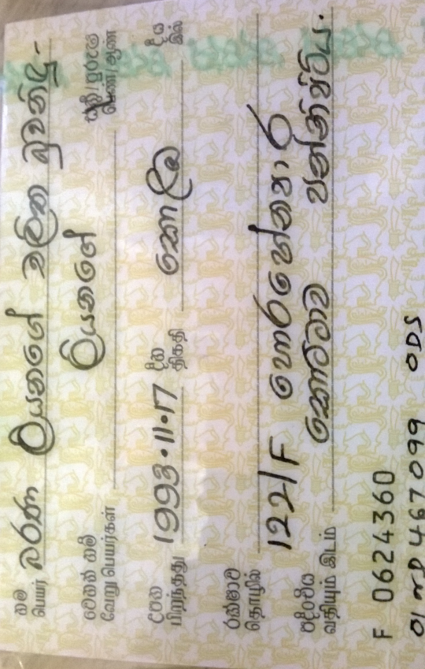 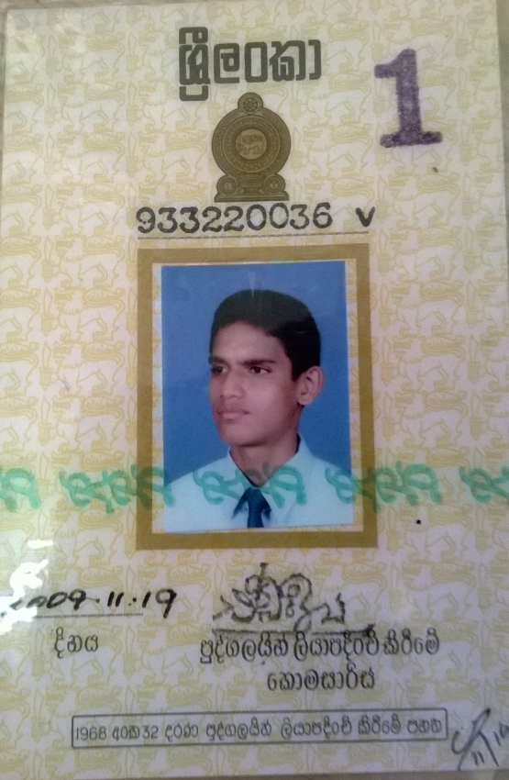

**UNI ID :**

 

**Name :** Barana Liyanage Chalitha Buwanidhu Liyange.

**Id no :** 933220036v

**Address :** 122/F, Horahena Road, Kottawa, Pannipitiya.

**Package** : 5.5Gb (Data).

**Contact No :** 071 195 54 39